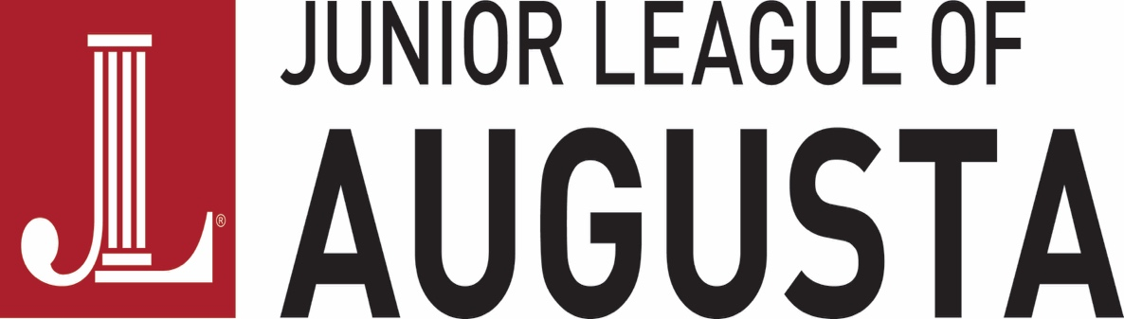

2017-18 Community Enabling Fund Guidelines and General Information

The Community Enabling Fund (CEF) allows the Junior League of Augusta, Georgia, Inc. to appropriate monies in a flexible manner to non-profit community agencies that render services within the CSRA. The monies allocated may be up to 50% of monies budgeted for projects into a fund that is determined by the Finance Council and reflected as a line item in the budget. No grant may exceed 15% of the total amount allocated to this fund.

The Junior League Community Council will determine the designation and amounts of individual grants. CEF applications need to be received to the Junior League of Augusta by 5 PM, Friday, September 29, 2017. Agencies will be notified regarding CEF funding by November 1, 2017 and awarded at our Holiday Market event November 12, 2017.

An application for a CEF is included herein. Applicants must:

1. Be a non-profit organization with tax-exempt 501(c)(3) status with the IRS.
2. Use these funds within the CSRA.
3. Have a local Board of Directors.
4. Have their request approved by the Community Council.
5. Have their proposal presented by an individual who is not a member of the Community Council.
6. Requests for religious or political purposes, fund-raising drives, capital campaigns, or travel expenses shall not be considered.

Grant recipients must submit a letter to the Junior League of Augusta, Georgia, Inc. within 90 days of receipt of the grant monies stating the expected timing and purpose of the use of the award. If an applicant is unable to spend said monies for the purpose for which the monies are granted, the funds must be returned to the Junior League of Augusta, Georgia, Inc. by September 1, 2018. Grant recipients must submit a completed evaluation form (attached) to the Junior League of Augusta, Georgia, Inc. subsequent to using the grant funds. Completed evaluation forms should be returned no later than September 1, 2018.

Ways to submit your application: E-mail, mail or hand deliver applications to:
Junior League of Augusta, Georgia
375 Highland Avenue, Augusta, Georgia 30909
Attention: Community Enabling Fund
OR
grants@jlaugusta.org

If you have any questions regarding these forms, please call the League office at
706-736-0033 or email grants@jlaugusta.org.

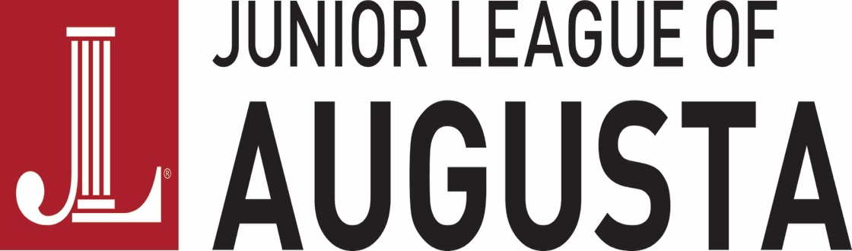

2017-18 COMMUNITY ENABLING GRANT APPLICATION

DEADLINE: APPLICATIONS NEED TO BE RECEIVED BY THE JUNIOR LEAGUE OF AUGUSTA, GEORGIA, INC. NO LATER THAN: 5:00 PM, Friday, September 29, 2017.

I. GENERAL INFORMATION

Date of Application: ____________

Name of Organization: ___________________________________________________

Address: ______________________________________________________________

Telephone number: (____) _____ - ________ Fax number: (____) _____-_____

E-mail address: ________________________________________________________

PERSONS TO BE CONTACTED FOR ADDITIONAL INFORMATION:

(1) _______________________________________________________________
Name Title Telephone number

(2) _______________________________________________________________
Name Title Telephone number

(3) _______________________________________________________________
Name Title Telephone number

II. PROJECT INFORMATION: PLEASE DESCRIBE PROJECT FOR WHICH FUNDS ARE REQUESTED AND SUBSTANTIATE NEED FOR PROJECT. PLEASE, INCLUDE THE FOLLOWING:

(1) Purpose of Organization:

(2) Critical Need to be addressed by the Project:

(3) Specific Objective:

(4) Profile of Client Group Served (Who and How Many):

(5) Timetable for Project, Including Use of Funds:

Total Project Cost: $ _____________

Amount Requested from Community Enabling Fund: $ ___________

III. MISCELLANEOUS

Please list other funding support (in-hand and pending), including sources and amounts.

Does your organization utilize volunteers? If so, how many and in what capacity?

Has your organization ever been funded by the Junior League of Augusta, Georgia, Inc.? If yes, when and for what purpose?

IV. SUPPORTING DOCUMENTATION

Please include the following supportive materials with your application:

1. A copy of your organization’s most current audited financial statement, including the independent auditor’s report.

2. This year’s operating budget with income and expenses to date.

3. A detailed budget for this project outlining how the funds will be used.

4. A copy of your organization’s 501(c)(3) authorization letter.

5. A list of the names and addresses of your organization’s Board of Directors.

6. Any other information you would like to submit supporting your organization’s application.

_________________________
Signature, Board President

_________________________
Signature, Executive Director

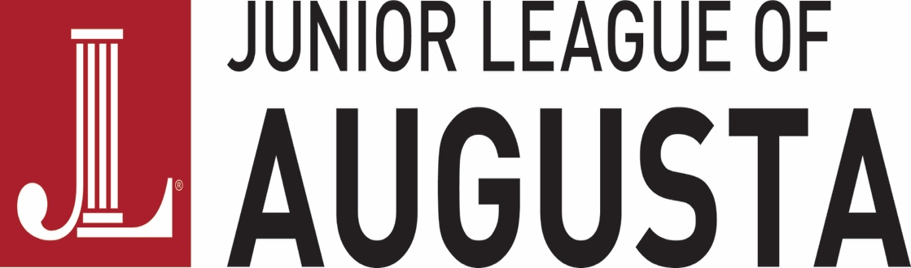

COMMUNITY ENABLING FUND - GRANT EVALUATION

A TIMETABLE FOR SPENDING IS DUE TO THE JUNIOR LEAGUE (ATTENTION: CEF) WITHIN 90 DAYS OF RECEIPT OF GRANT MONIES.

Name of Organization: ________________________________________________
Address: ________________________________________________
Contact Person: ________________________________________________
Telephone Number: ________________________________________________
Name of Project: ________________________________________________

Amount Received by Community Enabling Fund: $

How and when was the Community Enabling Fund money used? Include supportive documentation (i.e. photographs, receipts, etc.).

Was your organization able to achieve its goal? Describe how, and if not, why.

Did your organization publicize this grant in any manner? If so, please explain and document, if possible.

Other comments:

By: ______________________ Date: __________________

